Populating an array
#include<conio.h>
#include<stdio.h>

int main()
{
//declare the array variable - state data type, name of array and
//maximum number of elements it can hold
int numbers [10];

//populate the array
for (int count = 0; count < 10; count++)
{
printf("\nPlease enter number %d:\t", count+1);
scanf("%d", &numbers[count]);
}
getch();
return 0;
}

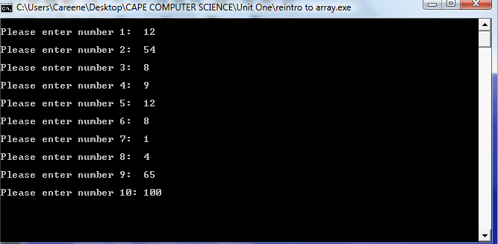

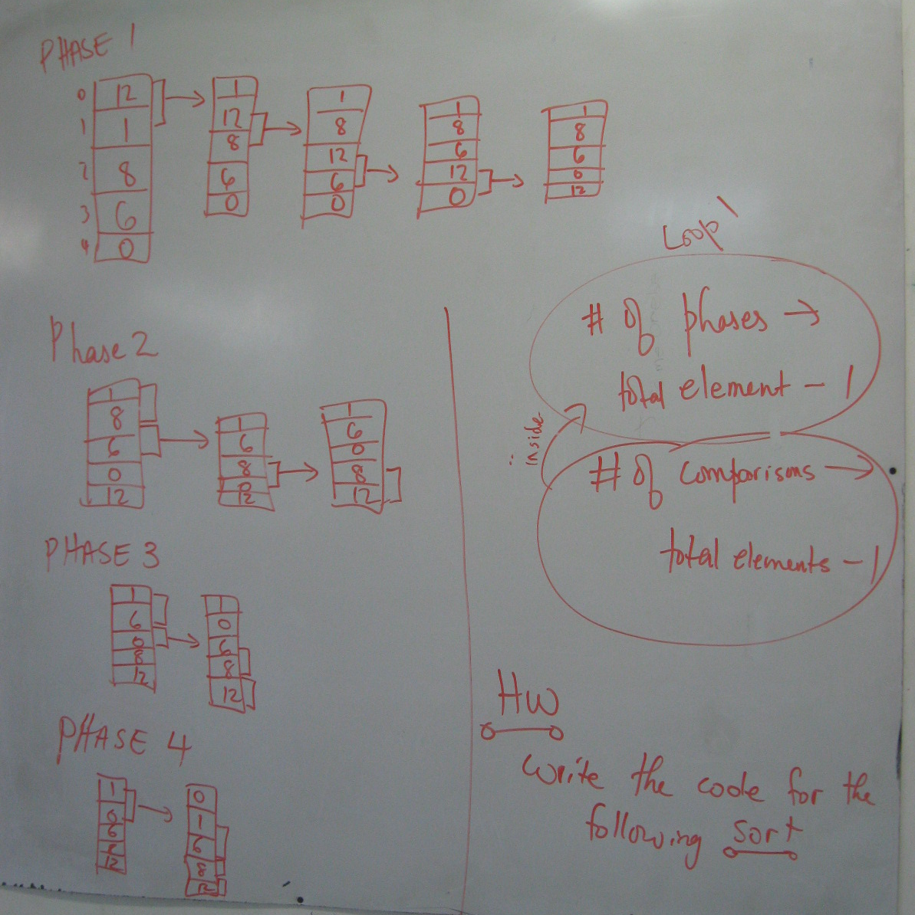
Introduction to Sorting
(how would u sort?)

